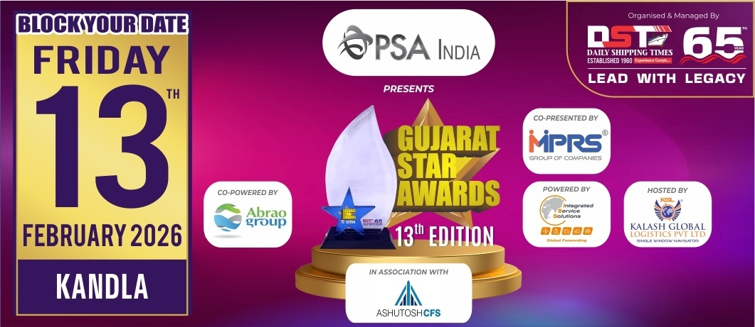
Nomination Form
Information should be relevant to
FY 2024-25 & for Gujarat Region only
(Jury Chairman will disqualify the papers if it is not related to Gujarat)
Note : Please mail back the details on nominations@gujaratstarawards.com

Award Category : BEST DIGITAL SOLUTION PROVIDER
OF THE YEAR

Award Criteria :-
Services offered through Digital Platform, New Innovations & Customer Satisfaction.
Please Note : Last date for Filing Nomination is 3rd November, 2025

Contact Information :-

Name of the Company :-
Contact Person :-
Designation :-
Contact No. :-
Email Address :-

Services offered through Digital Platform :-

New Innovations :-

Customer Satisfaction (Maximum 5 letters) :-

