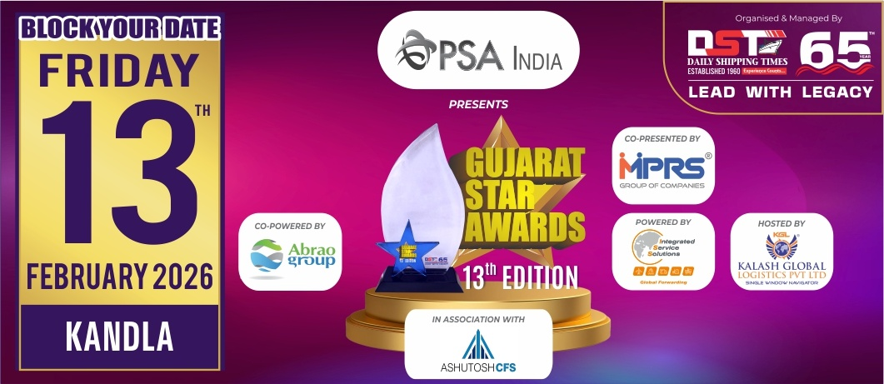
Nomination Form
Information should be relevant to
FY 2024-25 & for Gujarat Region only
(Jury Chairman will disqualify the papers if it is not related to Gujarat)
Note : Please mail back the details on nominations@gujaratstarawards.com

Award Category : BEST CONTAINER FREIGHT STATION
OF THE YEAR - SPECIFIC

Award Criteria :-
Volume Handled in per Unit Area, Year on Year Growth, Introduction of
New Customer Friendly Facilities, Turnaround time of Export & Import Containers, Customer Satisfaction.
Please Note : Last date for Filing Nomination is 3rd November, 2025

Contact Information :-

Name of the Company :-
Contact Person :-
Designation :-
Contact No. :-
Email Address :-

Volume Handled in per Unit Area (April 2024 to March 2025) :-

Year on Year Growth (Kindly mention figures for Last 3 years & growth percentage) :-

YEAR VOLUME GROWTH %
2024-2025

2023-2024

2022-2023

Introduction of New Customer Friendly Facilities :-

Turnaround time of Export & Import Containers :-

Customer Satisfaction (Maximum 5 letters) :-

